Jacob Howard

ELEC 2210 (Tuesday, 1:00pm-2:50 pm)

8/24/2020

**Objectives**

During this week’s laboratory experiment we worked on a more self-paced type of work. By using a digital program to simulate circuit design, we were able to use different components to construct a circuit. Transitioning from designing counters in paper to actually making them in a virtual circuit and eventually into a physical circuit is something I consider very important in this major. Taking this step towards designing circuits on an ELVIS board gives students a very hands-on experience that is necessary for future projects. Same as last week’s experiment, we used the information obtained to write a report that will help us with our professional written skills.

**Laboratory experiment**

This laboratory consisted of 4 different steps. For the first step we were introduced to the software that will help us designing virtual circuits, Multisim. This program has infinite options of components that we can use very easily. In this step we were introduced to some of the most common components we will use. By reading and following a 10 minute tutorial we learnt a variety of skills that range from making a wired connection to using a JK flip flop with interactive digital constants.

For the Step number 2 we used the circuit we previously designed for the pre-lab. This circuit is a 3 bit binary counter. The objective is to design a circuit that can count from 000 to 111 and export the output to a hexadecimal digital display. I consider that this step was hard because it depended strictly on out ability to design a circuit. I had a lot of trouble trying to set it up properly and was not able to make it work entirely. The RESET command works perfectly but the digital display would only jump from 0 to 3 and 7, jumping over the rest of numbers. The circuit I came up with will be displayed in *Image 1*.

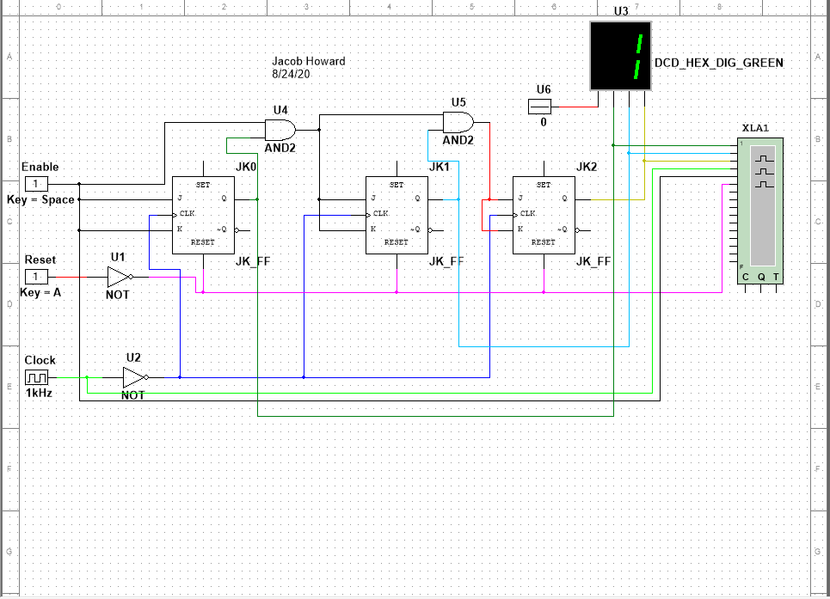

*Image 1*

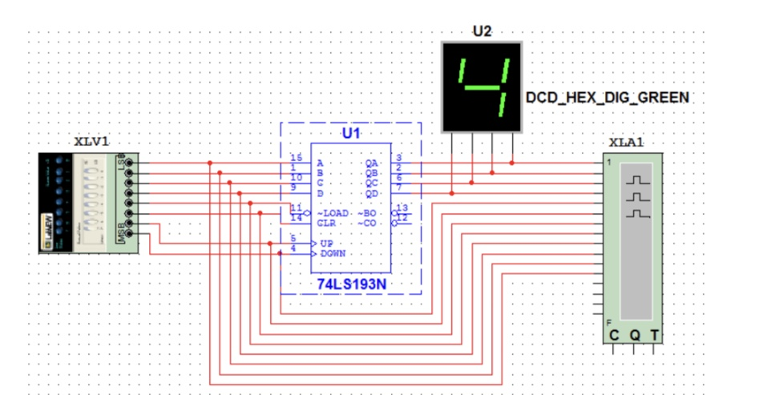In step number 3 we did something similar to what was done in the previous step, but this time we were provided with a sketch of the working circuit. I consider that this made everything so much easier for me. In this step we constructed a 4 bit binary counter based on *Image 2*.

*Image 2*

This binary counter is based on the previously studied 74193 chip. By making the appropriate connections to the 74193, and with a virtual version of the ELVIS Digital Writer, and a logic analyzer it was able to get all the functions of the binary counter to work. The RESET function would set the value to 0 and after every “UP” pulse, the number shown in the digital display would increase appropriately. The circuit is shown in the *Image 3*.

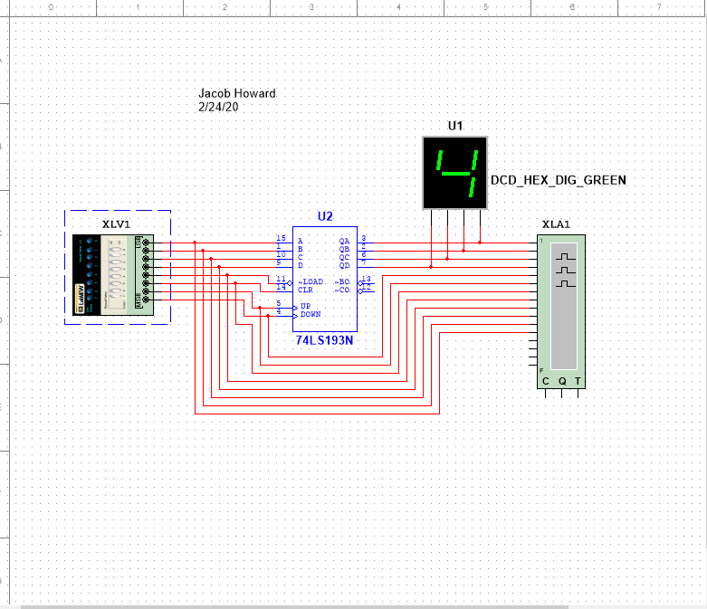

*Image 3*

Step number 4 of the experiment only required us to send the Multisim files to our TA for a better look at out designs.

**Conclusions**

This experiment was helpful by showing us a different way to design circuits. Multisim is a great tool for electrical engineers, or whoever needs to design a circuit. With the basically infinite amount of components it is really easy to sketch a circuit and making sure that it works before wiring it up in an ELVIS board. It would have been very helpful to have a sketch of the 3 bit binary counter because by making a simple mistake in the design, the entire counter could stop working. Other than that I didn’t have any problems with the experiment, considered it a big. Learning experience.